Contents

**jobs command** 1

• To see job status 1

• To bring job in foreground 1

• To run job in background 1

• To run job directly in background, append & at the end 1

• To kill a job 1

• Detailed information about jobs using ps 1

# 

# **jobs command**

* job control is the ability to stop/suspend the execution of processes/command and continue/resume execution of process/command as per requirement.
* One job can read input and keyboard generated signals from particular terminal at a time. Job is part of exactly one session, the one belonging to its controlling terminal.

For an example, command is running in 1st terminal and one job is assigned to that terminal only. We cannot see job status of that process in different terminal.

* To see job status,

Command: jobs

|  |  |
| --- | --- |
| **Option** | **Description** |
| -l | detailed information |
| -p | PID |
| -r | display only running processes |
| -s | display only stopped processes |

|  |  |
| --- | --- |
| while running job | shortcut |
| suspend a job | ctrl+z |
| terminate a job | ctrl+c |

* To bring job in foreground,

Command: fg %<job ID>

Example: fg %1

* To run job in background,

Command: bg %<job ID>

Example: bg %1

* To run job directly in background, append & at the end.

Command: <command> **&**

Example: sleep 100 &

* To kill a job,

Command: kill %<job ID>

Example: kill %1

* Detailed information about jobs using ps,

Command: ps j

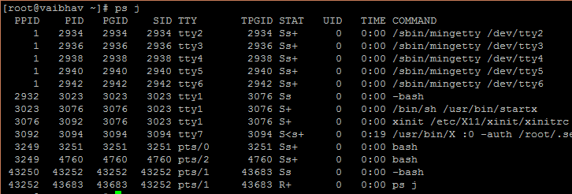

PID: Process ID

PPID: Parent process ID

PGID: Process Group ID (Process group Identifier/Process group leader)

SID: Session ID (session identifier/Session leader)

TPGID: ID of the foreground process group on the TTY (terminal) that the process is connected to, or -1 if the process is not connected to a TTY.

